The UKRAINE Network Newsletter ◊13◊ (No. 1, 2018) January-March 2018
Dear colleagues,  With this 13rd issue of our Newsletter we wish you a happy Easter! In this issue we announce the call for our PhD Presentation Contest 2018, report about the second part of the German-Ukrainian Forum of Young Researchers, and, as always, provide you with a digest of the latest news and selected funding opportunities related to academic cooperation with Ukraine.  With kind regards, | Шановні колеги!  Цим 13-тим випуском нашого інформаційного Вісника ми бажаємо Вам щасливих Великодніх свят! У цьому числі ми оголошуємо прийом заявок на наш черговий конкурс презентацій аспірантів 2018, інформуємо про другу частину Німецько-Українського Форуму Молодих Дослідників та, як завжди, хочемо привернути Вашу увагу до деяких цікавих новин та актуальних грантових пропозицій, пов'язаних з науковою співпрацею з Україною.  З найкращими побажаннями, | Sehr geehrte Kolleginnen und Kollegen,  Mit dieser 13. Ausgabe unseres Newsletters wünschen wir Ihnen Frohe Ostern! Wir kündigen den Doktoranden-Vortragswettbewerb 2018 an, berichten über den 2. Teil des Deutsch-Ukrainischen Forums der Nachwuchswissenschaftler, und, wie immer, bieten einige interessante Informationen und Hinweise zu aktuellen Fördermöglichkeiten.  Mit freundlichen Grüßen,
Dr. Oksana Seumenicht
Department of Strategic Cooperations and Research Funding, Max Delbrück Center for Molecular Medicine, Berlin
Professor Olga Garaschuk
Chair of the Department of Neurophysiology, Eberhard Karls University of Tübingen

CONTENTS:
- Community corner
- Awards and Prizes
- Cooperation highlights
- News from Ukraine
- Event Report
- Funding opportunities
- Forthcoming events
- Quick & useful

Acknowledgements
Special thanks to Oleg Bezshyyko, Jochen Fornasier, Olesia Lazarenko, Yana Liashko and Pablo Markin for their valuable contributions to our LinkedIn group discussions and news items included in this issue.
COMMUNITY CORNER
Save the Date: 2018 ANNUAL MEETING will take place in Dresden on 4-5 October
The next Annual Meeting of the German-Ukrainian Academic Society will take place in Dresden (Meeting Chair: Dr Denys Makarov, Helmholtz-Zentrum Dresden-Rossendorf):
- the part, open to public, will include the 2018 Final of the PhD Thesis Presentation Contest and a Networking Get-Together on Thursday 4.10 (17:00 – 21:00);
- the annual meeting of the society members will take place on Friday 5.10 (9:00 - 12:30).
2018 PhD THESIS PRESENTATION CONTEST: Call for applications is open
PhD students carrying out their research in any subject are eligible to apply for participation in this Contest. In particular we invite PhD students from one or more following groups to apply:
- Ukrainian PhD students studying abroad (incl. exchange PhD students);
- PhD students, regardless of nationality, who are involved in a collaborative (e.g. bi- or multi-lateral, including Ukraine as a partner) research project;
- PhD students, regardless of nationality, whose topic of research relates to Ukraine.
Ukrainian PhD students studying in other than Germany European country can also apply. If you have questions or any doubts about your eligibility, please contact us: info (at) ukrainet.eu. The Final will be carried out on 4th of October 2018 in Dresden, Germany, within the framework of the 2018 Annual Meeting of the German-Ukrainian Academic Society (Die Deutsch-Ukrainische Akademische Gesellschaft e.V.). To apply please fill in the application form (follow the link below) and send your CV to e-mail: info (at) ukrainet.eu by 14 May 2018. Finalists will be informed by the end of June 2018. Their travel and stay in Dresden will be supported by the Society. This contest is supported by Nomad Bioscience GmbH and the Embassy of Ukraine in Germany. For more information please read the FAQs available at our web-site.
https://www.surveymonkey.com/r/NJSQSM5
FORTHCOMING TALK as part of the Lecture Series “Science first hand” in BERLIN (in German)
Topic: | On the banks of the Bug. German-Ukrainian excavations in the ancient city Olbia Pontike/ An den Ufern des Bugs. Deutsch-ukrainische Ausgrabungen in der antiken Stadt Olbia Pontike
Speaker: | Prof. Jochen FORNASIER, Goethe-Universität Frankfurt am Main, Institute for Archaeologic Sciences, Classical Archaeology
Date & Time: | Thursday, 7 June 2018, 18:00 – 19:30
Venue: | Embassy of Ukraine in Germany, Albrechtstraße 26, 10117 Berlin
Registration is mandatory at berlin@ukrainet.eu. Person identification documents are required. The talk will be held in German, questions could also be asked in English and/or Ukrainian.

AWARDS & PRIZES
Ukrainian-American mathematician VLADIMIR DRINFELD shares the 2018 Wolf Prize for Mathematics
The 2018 Wolf Prize for Mathematics has been awarded to Prof. Alexander Beilinson and Prof. Vladimir Drinfeld, both from the University of Chicago, for their groundbreaking work in algebraic geometry, representation theory, and mathematical physics.
Vladimir Drinfeld was born in Kharkiv, Ukraine. In 1969, at the age of 15, he represented the Soviet Union at the International Mathematics Olympiad in Bucharest, Romania, and won a gold medal with the full score of 40 points. He was, at the time, the youngest participant to achieve a perfect score. Drinfeld was awarded the Fields Medal in 1990. From 1981 till 1999 he worked at the Verkin Institute for Low Temperature Physics and Engineering (Department of Mathematical Physics) in Kharkiv. Drinfeld moved to the United States in 1999 and has been working at the University of Chicago since January 1999.
http://mfa.gov.il/MFA/PressRoom/2018/Pages/Laureates-of-2018-Wolf-Prize-announced-12-February-2018.aspx
DENYS ZHADANOV (Odesa, Ukraine) selected to the Forbes "30 Under 30 - Europe - Technology" list
Denys Zhadanov is Vice President of Readdle, a company that has built a powerful ecosystem of productivity apps such as Spark, Documents, Scanner Pro, Calendars and PDF Expert. Readdle's apps are considered to be category leaders with over 80 million downloads worldwide, the "App of the Year" runner-up award for PDF Expert for Mac from Apple in 2015, and top positions on the App Store charts for Spark email client. Denys Zhadanov is based in San Francisco, California. He graduated in management and business from Odesa National I.I. Mechnikov University.
https://www.forbes.com/profile/denys-zhadanov/
Anne Applebaum Wins the 2018 Lionel Gelber Prize for her Book “Red Famine”
The winner of the 28th annual Lionel Gelber Prize is Anne Applebaum for her book Red Famine: Stalin's War on Ukraine, published by Signal/McClelland & Stewart/Penguin Random House. "Anne Applebaum's Red Famine: Stalin's War on Ukraine is the gripping story of the famine the Soviet leadership induced in Ukraine. This beautifully written history speaks to one of the most important global issues. Famines, then and now, are never the result of natural causes only; they are also the result of deliberate choices that leaders make. This is a magnificent book about a globally important issue that everyone should read," said Jury Chair Janice Stein.
https://munkschool.utoronto.ca/gelber/
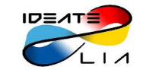 | Laureates of the LIA competition of students’ projects (France) have been announced
The International Associated Laboratory LIA IDEATE covers R&D and optimization of innovative technologies for the experiments at the particle accelerators and development of accelerator techniques since 2007. On March 7, 2018 the LIA IDEATE organized at the French Institute (Kyiv, Ukraine) the Conference of students’ projects in cooperation with CNRS, Le Commissariat à l'énergie atomique et aux énergies alternatives (CEA), L'Université Paris-Sud, Science & Technology Center in Ukraine, Embassy of France in Ukraine, French Institute, Campus France and L'Alliance française. 22 students from Ukrainian universities took part in this competition. Three students were selected by the jury as winners of this competition:
- Borys Knysh: "Studying the photon polarization with B → Kππγ angular analysis in the Belle II Experiment", Department of Nuclear Physics, Faculty of Physics, Taras Shevchenko National University of Kyiv
- Barynova Kateryna: "Detectability of short gamma-ray bursts by ECLAIRs", Department of Nuclear Physics, Faculty of Physics, Taras Shevchenko National University of Kyiv
- Oleksandr Burlayenko: "Intrinsic safety of advanced fast reactor working in the nuclear burning wave mode", O.I. Akhiezer Department of Theoretical Nuclear Physics and Higher Mathematics of the Faculty of Physics and Technology, V.N. Karazin Kharkiv National University
Moreover, Vsevolod Yeroshenko (also from the Department of Nuclear Physics, Faculty of Physics, Taras Shevchenko National University of Kyiv) was also distinguished for his talk "Development and Tests of First Prototypes of fTOF Detector". In the summer of 2018, all the laureates will visit the Linear Accelerator Laboratory (Le Laboratoire de l'Accélérateur Linéaire, Orsay, France) and CERN.
www.univer.kharkov.ua/ua/general/univer_today/news?news_id=7682
https://ideate.lal.in2p3.fr/en/lia-competition-of-students-projects/
COOPERATION HIGHLIGHTS
Digging the Past – Shaping the Future: German-Ukrainian Excavation Project in the Ancient Greek Colony of Olbia Pontike (Mykolaiv Oblast, Ukraine)
By Jochen Fornasier, Goethe-Universität Frankfurt am Main
Since August 2014, in a framework of a very successful German-Ukrainian cooperation (led by Prof. Jochen Fornasier and Dr Alla Buyskikh) between the Institute for Archaeological Sciences of the Goethe University Frankfurt/Main and the Institute for Archaeology of the National Academy of Sciences of the Ukraine in Kyiv, joint investigations are carried out in the suburb of the ancient Greek colony of Olbia (modern Mykolajvs’ka oblast’). Our international research project is funded by the German Research Foundation (DFG), with pilot studies being supported by the Fritz Thyssen Foundation (Cologne, Germany), for which we are very grateful to both institutions.
The project pursues an interdisciplinary approach: for the first-time archaeological field work is supported and complemented by geophysical investigations. Furthermore, researchers are able to improve typological and stylistic comparisons of ancient pottery by using archaeometric analyses. Finally, also archaeobotanical analyses commenced in 2017, which will allow to reconstruct the daily life and diet of the ancient city’s inhabitants. In short, by using modern diagnostic methods German and Ukrainian scientists are investigating Olbia’s suburb and thus part of the city’s history from the 6th – 4th century BCE.
The area of excavation is located west of the central part of the Olbian city. Nothing was known about the suburb until the late Ukrainian archaeologist Julia Kozub quite unexpectedly discovered some remains of settlement in 1964. Initially searching for a Roman necropolis, in the strata of the 5th century BCE she discovered large pits, partly or completely deepened in the ground, representing clear settlement structures. These so-called dugouts or semi-dugouts are a characteristic phenomenon for the Northwestern Pontus region for the early period of Greek colonization. Based on Kozub’s results, geophysical surveys in the Olbian suburb could be carried out for the first time in August 2014, with the aim to find the best-suited area for our new excavation project. Using this method, the ground can be scanned quickly and non-destructively for interesting structures relating to the matter in question. Subsequently, an international team of scientists and students from Kyiv, Charkiv and Frankfurt began with the actual on-site field work in July 2015.
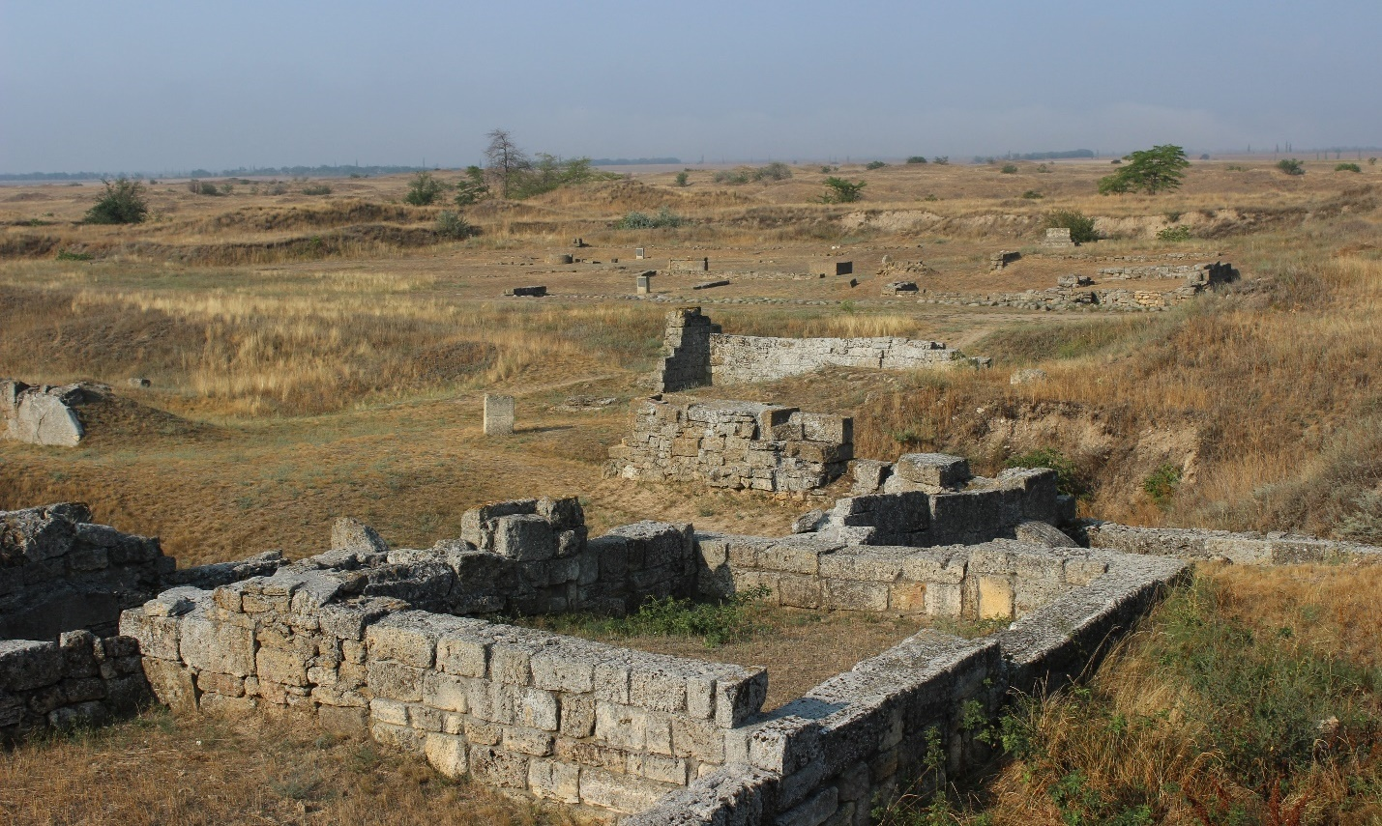
Photo: Jochen Fornasier, Goethe-Universität Frankfurt am Main
Already in the first three years of geophysical surveys and archaeological excavations important results were achieved and numerous questions about the genesis, structure and architectural characteristics of the suburb could be answered. Significant results were also obtained regarding the size of the suburb, which had so far been unknown. According to the new geophysical measurements, a wall-and-ditch system could be traced over 450 m. So, for the first time in Olbia’s research history, archaeologists could measure the size of the suburb, which matches the city proper in terms of dimensions. According to our current state of knowledge, the fortification was built in the 5th century BCE.
Thanks to the generous support from the DFG, we are now starting a new three-year research project in April 2018 focused on the topic of the development, production and use of money and coins in Olbia from the archaic to the early Hellenistic period. Together with our Ukrainian colleagues, we are pursuing a novel interdisciplinary research approach that combines archaeology, numismatics and metallurgy. Specifically, the study is conceived as a PhD dissertation project, which provides an ideal environment and network for research and training.
Finally, this partnership is a true collaboration activity, taking particular care that all activities are performed jointly by the participants from both countries. Working together, exchanging experiences, getting to know better the homeland of the other party through personal talks and organizing symposia at the end of each summer campaign – in addition to rather remarkable scientific results, these are very important aspects of international cooperation that contribute to better preparing young scientists for future joint projects.
Joint Ukrainian-Turkish Coordination Center for Scientific & Technical Research has been launched in Kharkiv
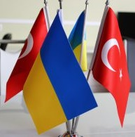Photo: NTU “KhPI” | The delegation from Istanbul Technical University (İTÜ) paid a two-day visit to National Technical University “Kharkiv Polytechnic Institute” (NTU “KhPI”). On February 1, a grant opening of The Ukrainian-Turkish Coordination Center for Scientific and Technical Research was held at the KhPI. The participants stressed that the main task of Center is to speed-up the commercialization process of scientific developments.
The signed association agreement between the NTU “KhPI” and İTÜ foresees joint research projects and development of innovative technologies in fields of electronics, mechanical engineering, space, aviation, etc. Specifically, the NTU “KhPI” and the İTÜ plan to work together on the development of internal combustion engines, transmission systems, electronic control units and novel materials. The İTÜ will manage joint programs on diesel power generating units in cooperation with the faculty of NTU “KhPI”. The İTÜ will also offer scholarships for Turkish students to participate in Master’s and PhD programs at the NTU “KhPI”. In addition, the universities will carry out joint research projects related to powerpack engine technologies, material science and other coordinated programs.
www.kpi.kharkov.ua/eng/2018/02/02/new-scientific-center-and-agreement-khpi-itu/
Göttingen-Kyiv Partnership in Law Sciences
By Yana Liashko, German Law Center of the National Taras Shevchenko-University of Kyiv
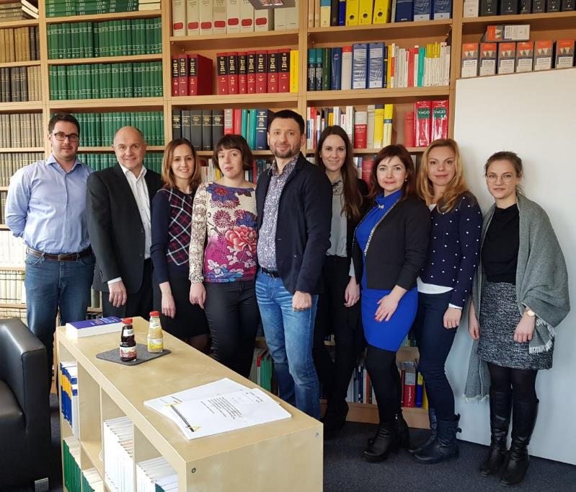
Left to right: Bellroth Dag, Prof. Thomas Mann, Anna Yushchak, Maryna Rabinovych, Prof. Roman Melnyk, Sina Fontana, Olha Kosilova, Iryna Lukach, Franziska Schnuch. Photo: courtesy of German Law Center of the National Taras Shevchenko-University of Kyiv
From the 5th to 8th of February 2018 the group of young researchers from Ukraine visited the University of Göttingen within the framework of the project “Conditions for the functioning of the 3rd branch of government”. This project is a result of further development of long-standing cooperation between the Juridical Faculty, German Law Center of the National Taras Shevchenko-University of Kyiv and the Institute of Public Law of the Göttingen University (see the previous Issue of this Newsletter for more information) and is funded by the Alexander von Humboldt Foundation. During this visit the Ukrainian researchers were introduced to the principle of independence in the German judicial system by the judges from Göttingen administrative court and had an opportunity to observe the real-life civil proceedings in the court. They also established research tandems with German partners based on a range of topics of joint interest. Currently all the participants are working on the respective papers to be compiled together as co-authored chapters of a joint publication, and are looking forward to the future joint workshops and meetings. The participants were also grateful to their German colleagues for an excellently designed cultural program that included a city tour, visit to the historical university building and an excursion to the beautiful surroundings of Göttingen.
NEWS FROM UKRAINE
23rd Ukrainian Antarctic Expedition departed to Antarctica
On the 22nd of March 2018 two scientific expeditions left to the Ukrainian Antarctic Station “Academic Vernadsky”. Ministry of Education and Science (MES) of Ukraine has approved a total budget of UAH 72 million (approx. €2,2 million), which included additional UAH 15 million for major repairs. First one-year expedition will be carried out by 12 research and technical staff members, who will carry out meteorological, biological and geophysical experiments. The second, seasonal expedition, consisting also of 12 researchers will last for almost three weeks. They will carry our experiments and collect samples for more than 20 research institutions of Ukraine. The next seasonal expedition is planned to last three months starting in December 2018. Immediate plans include improving the technical state of the station, the restoration of marine research in the Southern Ocean and the development of a new State program of research in Antarctica for 2021-2030 years. Strategic plans include expanding research to Arctic and the revival of the Ukrainian scientific fleet.
(in UA) https://mon.gov.ua/ua/news/vivchati-ozonovu-diru-magnitne-pole-ta-pingviniv-na-stanciyu-akademik-vernadskij-yide-23-ya-ukrayinska-antarktichna-ekspediciya
Web-site of the National Antarctic Scientific Center of Ukraine and the Ukrainian Antarctic Vernadsky Station (65 ° 15 'S, 64 ° 15' W): www.uac.gov.ua/en/SitePages/AcademikVernadskyStation/Vernadsky_station.aspx
Roadmap for Ukraine's Integration into the European Research Area (ERA-UA) has been approved
The Collegium of the Ministry of Education and Science (MES) of Ukraine has approved The Roadmap for Ukraine's Integration into the European Research Area (ERA-UA). This is a strategic document required for long-term planning and development of further actions, such as a detailed action plan for the Roadmap implementation, which will specify milestones, necessary resources, etc. The ERA-UA Roadmap stipulates six key priorities of the development of:
- The effective national research systems;
- Optimal transnational co-operation and competition;
- Opened labor market;
- Gender equality in research;
- Effective exchange and transfer of scientific knowledge;
- International cooperation.
A large working group, which included representatives of different stake-holders, have been working on the development of this document for about four months. The working group included 60 representatives of various organizations and departments from Ministry of Education and Science and other ministries, relevant Committees of the Verkhovna Rada, National Academy of Sciences, branch academies, leading universities, international organizations and NGOs, etc. A wide range of national and international experts have also contributed to the discussions of the working group development of this Roadmap. Experience of various EU member states: Austria, Finland, Germany, Estonia, etc. was studied and taken into account during the development of this Roadmap.
(in UA) https://mon.gov.ua/ua/news/viznacheno-6-prioritetiv-integraciyi-ukrayinskoyi-nauki-v-yevropu-kolegiya-mon-zatverdila-proekt-dorozhnoyi-karti
RI-LINKS2U Report: Ukrainian Participation in Horizon 2020
83 organizations from Ukraine receives €17.23 million from the EU within Horizon 2020 program.
Statistics and Analyses of Ukrainian Participation in HORIZON 2020 (updated after 404 concluded calls), Nov. 2017: https://ri-links2ua.eu/object/document/481/attach/Statistics_and_Analyses_of_UA_Participation_in_H2020__updated_after_404_concluded_calls_.pdf
International Students in Ukraine
In March 2018 the First Ukrainian Forum of International Education took place in Kyiv. Speaking at this event, Minister Liliia Grynevych presented recent numbers of international students studying at Ukrainian universities and institutions of higher education. In 2017 India became the leading country, from which students come to study to Ukraine. About 30% of students come from post-Soviet countries. “Only over the past two years, the number of Ukrainian higher education institutions where foreign students are studying has increased from 185 to 228", said Liliia Grynevych. Currently more than 66,000 foreign students study in Ukraine, which is almost 20% higher compared to 2011 (53,664). In particular, the minister highlighted the significant contribution of the Ukrainian State Center for International Education (Український державний центр міжнародної освіти, УДЦМО) and the dedicated web-portal (http://studyinukraine.gov.ua), that was launched by the Center. This portal has a Guide to higher education in Ukraine, including a searchable database of Programs and Courses, Universities, information on how to apply, how to study and live in Ukraine, etc.
http://studyinukraine.gov.ua
http://studyinukraine.gov.ua/uk/forum/#

Success of Kray Technologies in Agrotech
Kray Technologies, a Ukrainian startup (now based in the US) attended TechCrunch Disrupt San Francisco 2017 and received $600,000 in investments. The company currently has three models of agrodrones, a new cropdusting technology, and is planning to develop and introduce 15 more models by Spring 2018. A Ukrainian IT and Entrepreneurship magazine, K750, writes about Kray Technologies’ journey, their 2018 agrotech goals, and their aspirations of venturing into militaristic technologies.
www.crdfglobal.org/news/kray-technologies-continues-making-strides-agrotech-market
(in UA), an article by Olga Dubens’ka in K750: http://k750.media/post/735
Company web-site: http://kray.technology/
EVENT REPORTS
SUPPORTING EARLY-CAREER RESEARCHERS AND FOSTERING GERMAN-UKRAINIAN SCIENTIFIC COOPERATION: German-Ukrainian Forum of Young Researchers (Part II, Germany, 02.2018)
On February 8, 2018, the second part of the German-Ukrainian Forum for Young Researchers started at the Embassy of Ukraine in the Federal Republic of Germany. Selected participants, - 10 German-Ukrainian research tandems with joint ideas for collaborative projects came to Berlin for an intensive workshop on "Grant Writing Skills". In the first Part of the Forum, which took part on December 7- 12, 2017, a group of 45 researchers from Germany and from different cities in Ukraine carried out an exploratory and networking tour "Research in Ukraine" and visited Kyiv, Lviv and Kharkiv (See the previous issue of this newsletter and the web-site for detailed reports and presentations). During the kick-off event for the Part II, Prof. Olga Garaschuk, neurophysiologist of the Eberhard Karls University Tübingen and the President of the German-Ukrainian Academic Society/ The UKRAINE Network, gave a lecture "Brain aging and new insights into Alzheimer's disease" within the lecture series "Science first hand", organized regularly in Berlin by the regional group of the German-Ukrainian Academic Society.
The participants of the second part of the Forum had an opportunity to further elaborate on their ideas for joint research projects and to learn at first-hand from experienced researchers with significant reviewing experience of grant applications and from experts in research funding. Moreover, research partners from Ukraine were offered an opportunity to visit the laboratory/ research institute of their prospective or existing cooperation partner in Germany in order to learn more about their current research and to discuss possible future joint projects.
The Forum was characterized by a particularly positive atmosphere and a lively scientific and cultural exchange. "I consider the Forum the most remarkable recent event on the Ukrainian scientific landscape in terms of geography, logistics and number of the involved people and institutions", said Dr Svitlana Potapenko, historian from Kyiv. Dr Maksym Tsizh, a cosmologist from Lviv, added: "All parts of the Forum were important – interaction with my partner, tips about writing proposals and the expert advice. I now have all contacts I need, and a solid plan for my next steps – all thanks to the Forum and the German-Ukrainian Academic Society". Both the participating young researchers and the experienced scientists who participated in the Forum have made new contacts and exchanged ideas. The talented young researchers with promising research ideas are now better equipped to advance their research careers and, in doing so, contribute to fostering German-Ukrainian scientific cooperation.
The organizers are grateful to the trainer Dr Julia Staykova-McKinnon (Scriptorium Training & Consulting) for her excellent tailor-made course and useful supporting materials. Expert advice and tips on funding and further development of joint proposals offered at the individual coaching sessions by Prof. Robert Luxenhofer (Chair for Chemical Technology & Material Synthesis, University of Wüerzburg), Dr Denys Makarov (Leader of the Research Group “Intelligent materials and devices”, Helmholtz-Zentrum Dresden-Rossendorf (HZDR)) and Dr Christian Schaich (Administrative Director, Centre for Eeast European and International Studies (ZOIS), Berlin) was extremely valuable to the participants. Special thanks to the DAAD Berlin office for their organizational support.
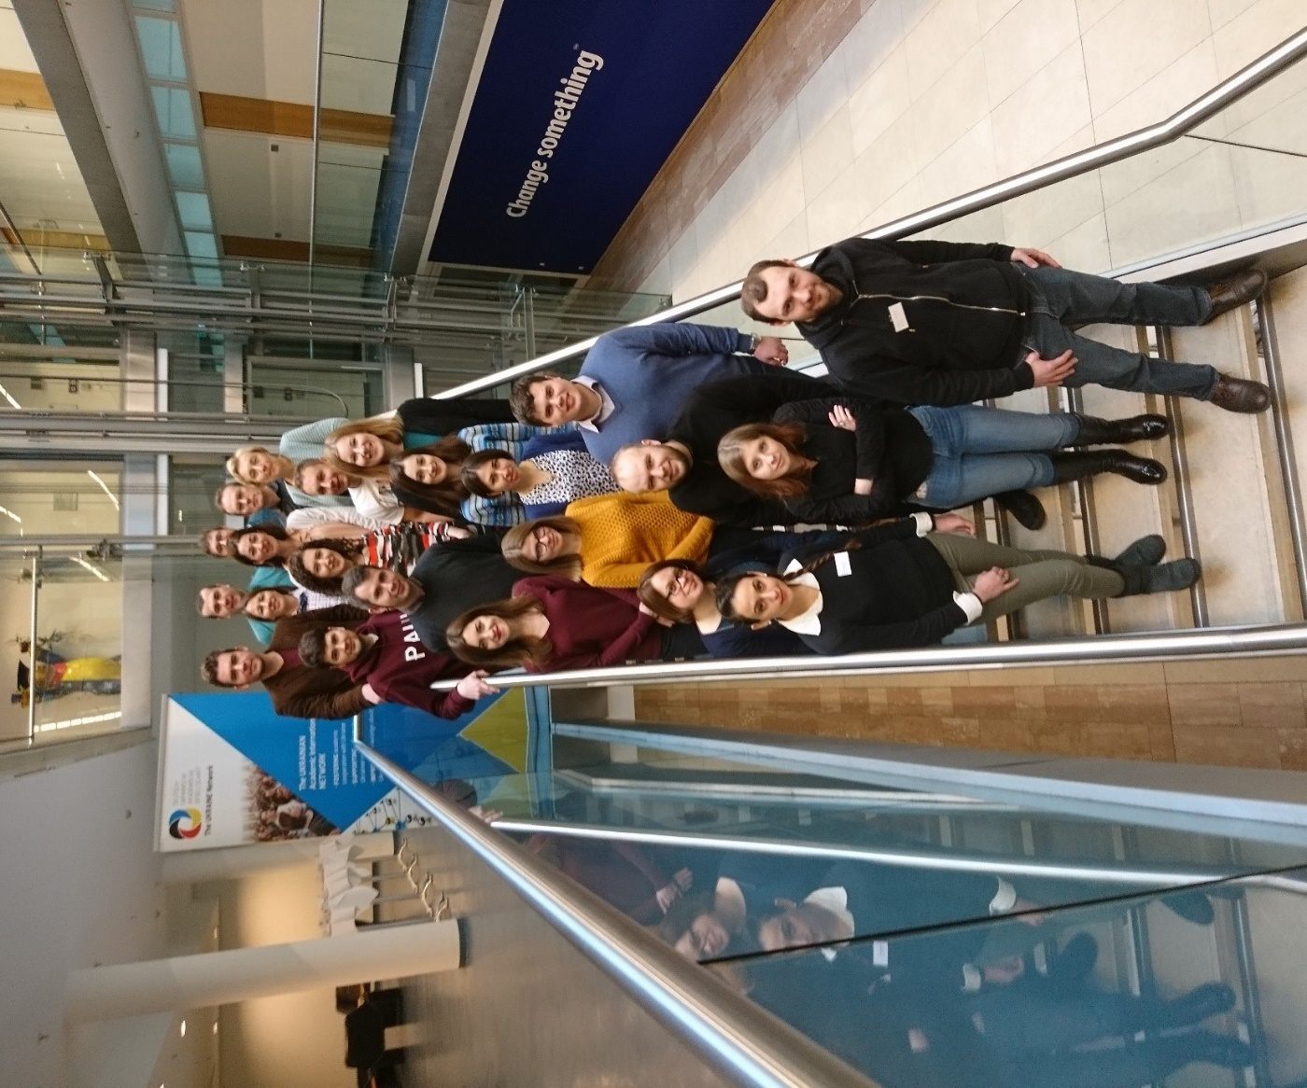
Forum participants in Berlin, 10 February 2018. © Dmytro Puchkov & Oleh Lushchak
This Forum was funded by the German Academic Exchange Service (DAAD) from the funds of the German Federal Ministry of Education and Research (BMBF).
http://ukrainet.eu/2018/02/21/report-de-ua-forum-feb2018/
III International Ukrainian Orthography Competition, Krakow
By Dr Olesia Lazarenko, European University Viadrina
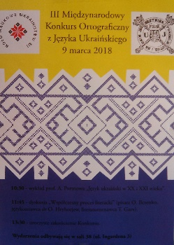 | From 8 to 9 March 2018, the III International Ukrainian Orthography Competition was held at the Institute of East Slavonic Philology at Jagiellonian University in Krakow (Poland). Representatives from 14 educational institutions from Poland, Serbia, the Czech Republic, Russia, Bulgaria took part in this year's contest, with representatives of Germany and Austria joining for the first time. This is especially significant, as 2017-2018 has been announced the Year of Ukrainian language in Germany and of German language in Ukraine.
This important event contributes to the intensification of the study of the Ukrainian language, in particular at such higher educational institutions as the Humboldt University of Berlin and the European University Viadrina (Frankfurt/Oder). Sergei Antonovsky (Moscow State Institute of International Relations, MGIMO), won the first place. Nikola Jankovic (Belgrade University) won the second place and Anna Filipiak (Adam Mickiewicz University, Poznań) won the third place.
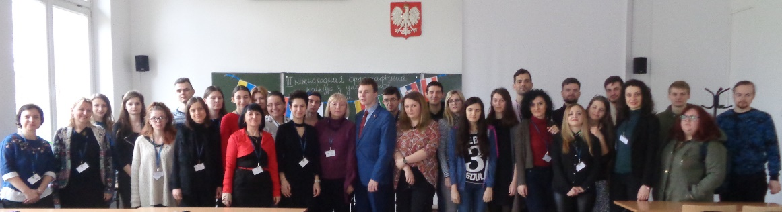
Photo: Courtesy of Dr Oksana Baranivska, Jagiellonian University
Such spelling competition in the Ukrainian language has been conducted in Poland for the last 13 years, and it has been expanded to students from other European countries, where the Ukrainian is being spoken and studied. Dr Oksana Baranivska, Senior Lecturer at the Department of Ukrainian Studies (Institute of East Slavonic Philology, Jagiellonian University) is the organizer and the inspiration of this Contest from its early days. In addition to the main parts of the contest (test and dictation), the competition was accompanied by a variety of cultural events, such as visiting the Museum of Jagiellonian University, reading poetry of Taras Shevchenko on the birthday of the great Ukrainian poet in the legendary theater cabaret “Pod Baranami”, a tour of the city of Krakow, etc.
(in UA): www.polradio.pl/5/38/Artykul/353380
(in PL): www.ifw.filg.uj.edu.pl/instytut/wydarzenia/-/journal_content/56_INSTANCE_Ymd6/1717115/139253477
(in RU): https://mgimo.ru/about/news/departments/student-mgimo-pobedil-na-mezhdunarodnom-konkurse-v-yagellonskom-universitete/

A SELECTION OF RELEVANT FUNDING & SUPPORT OPPORTUNITIES
For the up-to-date announcements visit our LinkedIn group: https://www.linkedin.com/groups/8473594
A list of currently opened EU calls maintained by the project ‘Strengthening Research and Innovation Links towards Ukraine’ (RI-LINKS2UA): https://ri-links2ua.eu/object/call/list
Culture Bridges Program Grants

Culture Bridges is a new program that supports the development of the cultural sector in Ukraine and enables it to engage more effectively with cultural organizations and operators in the EU. The program funds a range of activities including international mobility, national and international cultural cooperation projects, as well as training sessions and study visits to the EU member states. The second call for grant applications is now open to funding mobility projects. Further calls for proposals under Culture Bridges will be made every three months in 2018 and 2019. http://www.britishcouncil.org.ua/en/culture-bridges

Creative Europe - Culture- Literary translation, deadline for submitting: 2nd week of May 2018

The scheme offers grants to eligible publishers for the co-financing of the translation, publication and promotion of a "package" of minimum 3 and maximum 10 works of fiction.
https://eacea.ec.europa.eu/creative-europe/actions/culture/creative-europe-culture-literary-translation_en

Call for Joint Ukrainian-Czech Research Projects for 2019-2020, apply by 30 April 2018
Priority directions of research:
- IT, including new technologies in trade;
- Energy research;
- Ecology and use of environmental resources;
- Biotechnology, novel therapeutic methods, prevention of diseases;
- New substances and materials;
- Modern mechanical engineering;
- Social sciences and art.
https://mon.gov.ua/storage/app/media/news/%D0%9D%D0%BE%D0%B2%D0%B8%D0%BD%D0%B8/2018/03/01/konkursukr-chekhiya20192020.docx

Call for Joint Ukrainian-Latvian Research Projects for 2019-2020, apply by 15 May 2018
Priority directions of research:
- Energy and energy efficiency;
- Ecology and rational use of nature;
- New technologies for the prevention and treatment of major diseases, research in the field of biotechnology, bioengineering and genetics;
- Novel materials;
- Demographic change, migration and migrants;
- Features and problems of regional development and social cohesion;
- Defense-oriented technologies.
https://mon.gov.ua/storage/app/media/news/%D0%9D%D0%BE%D0%B2%D0%B8%D0%BD%D0%B8/2018/03/14/latviya-2018.doc

EaP PLUS Grants for Networking in Brokerage Events or Preparatory Meetings – 2nd call, closing date to apply: 31 May 2018, apply at least 1 month before the event
This scheme funds the participation of researchers from Eastern Partnership countries in Brokerage Events related to Horizon2020 and Preparatory Meetings for the development of H2020 project proposals. The 2nd round of the scheme will give special priority to applications concerning SPIRE (Sustainable Process Industry through Resource and Energy Efficiency) calls which are explicitly encouraging participation from EaP countries.
https://www.eap-plus.eu/object/call/123
https://www.spire2030.eu/
Bavarian Funding Programme for the Initiation of International Projects, apply by 4 June
This program (BayIntAn) provides assistance of up to maximum EUR 10,000 for establishing and strengthening the scientific cooperation between scientists at Bavarian state and state-supported non-state universities and international research institutes. The prerequisite for being funded is that the planned cooperation must include at least one international partner.
https://www.bayfor.org/en/research-funding/bayintan.php
EU: WIDESPREAD-03-2018, Twinning grants, apply by 15 November
Twinning aims at significantly strengthening a defined field of research in a university or research organization from a Widening country by linking it with at least 2 internationally-leading research institutions in other Member States or Associated Countries. In general, costs (up to 1 Mio per 3-year project) relating to administration, networking, coordination, training, management, travel costs are acceptable under a Twinning project.
http://ec.europa.eu/research/participants/portal/desktop/en/opportunities/h2020/topics/widespread-03-2018.html
EU: WIDESPREAD-04-2019, ERA Chairs, apply by 15 November
The ERA Chairs actions will support universities or research organisations with the objective of attracting and maintaining high quality human resources under the direction of an outstanding researcher and research manager (the "ERA Chair holder") and in parallel implementing the structural changes necessary to achieve excellence on a sustainable basis. The grant (up to EUR 2.5 million for 5 years) will cover the appointment of the ERA Chair holder and a number of team members (e.g. their salaries, recruitment costs, administrative costs, travel and subsistence costs). The grant will also provide a contribution towards measures aimed at facilitating structural changes in the institution (e.g. costs for trainings, meetings, publications and managing IPR. A minor part of the grant can be spent on equipment. The following cost categories will be ineligible costs: infrastructure costs; research costs (including consumables).
http://ec.europa.eu/research/participants/portal/desktop/en/opportunities/h2020/topics/widespread-04-2019.html
Funding for Individuals/ Fellowships
Latvian State Scholarships for the academic year 2018/2019
This scheme is aimed at foreign students, researchers and teaching staff for participation in summer schools at Latvian HEIs, deadline: 4 May 2018.
https://mon.gov.ua/storage/app/media/news/%D0%9D%D0%BE%D0%B2%D0%B8%D0%BD%D0%B8/2018/03/19/inform-byul.pdf
BAYHOST Mobility Grants 2018
Research sojourn of students and early-stage researchers
Advanced students and early-stage researchers from Eastern Europe or Bavaria have the possibility to apply – in cooperation with an academic supervisor from a Bavarian university – for mobility grants for a research sojourn in Bavaria or Eastern Europe (travel expenses/allowance, accommodation expenses; Maximum funding amount: EUR 1,000). The 2018 program’s focus is put on the region/countries: Western Balkan countries, Belarus, Russia and Ukraine. Deadline: 20 April 2018: www.uni-r.de/bayhost/medien/foerderung/mg_2018_research_sojourns.pdf
Internships in Eastern Europe
BAYHOST offers to students of Bavarian universities the possibility to apply for flexible internship grants in order to facilitate internships and gain experience in Eastern Europe. Maximum funding amount: EUR 450. Deadline: 28 May 2018.
www.uni-r.de/bayhost/medien/foerderung/ms_2018_praktika.pdf
FRANCE, Call for Visiting Fellow Research Stays in Paris 2018-2019, apply by 30 April 2018
The Max Planck Sciences Po Center on Coping with Instability in Market Societies (Max - Po) is welcoming applications from senior academics for 2–4-month research stays at Sciences Po in the heart of Paris. MaxPo offers office space and a stipend to help cover accommodation expenses in Paris. Applicants must have their own additional funding to cover living expenses. Visiting fellows will present their work in MaxPo’s seminar program.
www.maxpo.eu/downloads/MaxPo-Visiting-fellows_2018.pdf
Ukrainian Graduate Research Fellowships, apply by 15 May 2018
Yahad – In Unum invites applications for Ukrainian Graduate Research Fellows for a 3-month fellowship at its research center (Paris). Candidates in history and anthropology, specialized in and presently conducting research on WWII and the Holocaust are welcome. The candidates must be enrolled in second year of a Master's degree or PhD in history or anthropology and must be registered at an Ukrainian university. The topics and research fields tackled by the candidates in the frame of their academic education must be related to the history of the WWII and of the Holocaust in the occupied Soviet territories. The candidates must be fluent in English, Ukrainian and Russian, and are encouraged, but not required, to have proficiency in one of the following languages: German, French, Polish, Lithuanian, Romanian. Fellowship may start in September, 2018 and must be completed by December 21, 2018. Please direct enquiries to Patrice Bensim: p.bensimon (at) yahadinunum.org
EEGA@future: 3-month Postgraduate-Grants, apply by 1 June 2018
The ScienceCampus EEGA invites for applications by talented Postgraduate students (generally, the submission of the MA thesis should not date back longer than 12 months), who are intending to develop a PhD proposal in the field of research of the EEGA, i. e. Eastern European Studies, European Studies, Global and Area Studies, and the disciplines involved in the ScienceCampus.
http://leibniz-eega.de/call-applications-eegafuture-postgraduate-grants/
EEGA@future: Postdoc Grants for Preparation of Funding Applications, apply by 1 June 2018
Support for a research/coaching period (1-6 months) with the ScienceCampus EEGA in Leipzig, Halle or Jena is available.
http://leibniz-eega.de/call-applications-eegafuture-postdoc-grants-preparation-funding-applications-3/
GERMANY: Georg Forster Research Award, nomination deadline 31 October 2018
The Georg Forster Research Award is granted in recognition of a researcher's entire achievements to date to academics of all disciplines whose fundamental discoveries, new theories, or insights have had a significant impact on their own discipline and beyond and who are expected to continue developing research-based solutions to the specific challenges facing transition and developing countries. The award amount totals €60,000. The Alexander von Humboldt Foundation may grant additional funding of up to €25,000, particularly for participating in scientific conferences, additional material resources, e.g., specialist literature and scientific equipment for the nominee’s own institute, as well as for involving junior researchers.
https://www.humboldt-foundation.de/web/georg-forster-award.html
SWITZERLAND: SNSF Ambizione Research Grants for Foreign Researchers, apply by 1 November 2018
Ambizione grants are aimed at young researchers who wish to conduct, manage and lead an independent project at a Swiss higher education institution. The grants are awarded for a maximum of four years to PhD-holders with less than four years research experience after gaining the PhD. www.snf.ch/en/funding/careers/ambizione/Pages/default.aspx
GERMANY, Berlin: Einstein Guest Professorships and Einstein Junior Scholarships to foster academic freedom
The Einstein Foundation is committed to fostering academic freedom. Two special programs (Einstein Guest Professorships and Einstein Junior Scholarships) are offered temporary in order to reach this objective and to enable researchers who are experiencing constraints in their work around the world to come to Berlin for two years to pursue their research without undue restrictions or threats. First and foremost, the programs are intended to support top researchers from regions of conflict. Furthermore, they are directed at researchers from regions that experience subtle or direct restrictions of research, and who look for opportunities to return, migrate or cooperate with countries offering a work environment free of constraints.
https://www.einsteinfoundation.de/en/programmes/academic-freedom/
GERMANY: Alexander von Humboldt Foundation’s Georg Forster Research Fellowship for researchers from developing countries, no deadline
Support for individual researchers for research stays in Germany (6 - 24 months, could be split into 3 periods for senior researchers), for proposals relevant for the continued development of the country or region of origin.
https://www.humboldt-foundation.de/web/georg-forster-fellowship.html
EUROPE: FEBS Collaborative Experimental Scholarships for Central & Eastern Europe, no deadline
These 2-3-month scholarships are for the exclusive benefit of PhD students from Central & Eastern Europe who need to visit a well-funded laboratory in Western Europe for the purpose of carrying out experimental procedures that would be impossible in their home country because of a lack of resources. Applications may be made throughout the year, but should reach the Chairperson of the FEBS Fellowships Committee at least 2 months before the proposed starting date.
www.febs.org/our-activities/fellowships/collaborative-experimental-scholarships-for-central-eastern-europe/
Other Relevant Funding
EEGA@interaction: Thematic Workshops and Conferences, apply by 1 June
http://leibniz-eega.de/call-applications-eegainteraction-thematic-workshops-conferences-4/
A SELECTION OF FORTHCOMING EVENTS
7-25/05/2018  L’viv, Ukraine | Intensive Ukrainian Language Spring Program at the UCU (45 study units)  http://studyukrainian.org.ua/en/programs/ukrainian-spring
7/06/2018  Berlin, Germany | Lecture Series “Science first hand”: On the banks of the Bug. German-Ukrainian excavations in the ancient city Olbia Pontike (in German). Speaker: Prof. Jochen Fornasier, Goethe-Universität Frankfurt am Main, Institute for Archaeologic Sciences, Classical Archaeology. Register by 1 June: berlin (at) ukrainet.eu
June-July 2018  L’viv, Ukraine | School of Ukrainian language and culture at the UCU, 2-6 weeks  http://studyukrainian.org.ua/en/programs/Ukrainian_language_summer_school
28-29/06/2018  Berlin, Germany  Call for papers’ deadline: 15 April | Prisma Ukraïna Workshop “At Home: Jews and Muslims in Eastern Europe”  www.forum-transregionale-studien.de/nc/en/homepage/news-details.html?tx_news_pi1%5Bnews%5D=2125
27-29/06/ 2018  Halle (Saale), Germany | Leibniz Institute of Agricultural Development in Transition Economies (IAMO) Forum 2018 “Large-scale agriculture – for profit and society?” www.conftool.net/iamo2018
4-6/7/2018  Leipzig, Ukraine | Annual Conference of the Leibniz Institute for the History and Culture of Eastern Europe (GWZO) & the Leibniz ScienceCampus “Eastern Europe – Global Area”  The contributions are invited especially to the following subject areas:  The imprint of Eastern Europe through cultural encounters, transfers and interactions I The economic linkages of Eastern Europe and its relation to processes of migration I The approach to ecological challenges (environmental history) in Eastern Europe I Eastern Europe in public international law and the dynamics of international organizations I The relations of Eastern Europe with Africa, Asia and Latin America I Skepticism towards globalization and interdependencies in the present  For further questions: leibniz-eega (at) ifl-leipzig.de  http://leibniz-eega.de/event-calendar/?event_id1=41
7/07/2018  Odesa, Ukraine | #EECVC 2018: Eastern European Computer Vision Conference  http://eecvc.com/
13-15/07/2018  Leipzig, Germany | 26th Conference of junior scholars in the field of East European studies  http://leibniz-eega.de/event-calendar/?event_id1=41
16/07-2/08/2018  L’viv, Ukraine | L’viv Data Science Summer School at the Ukrainian Catholic University is aimed at undergraduates, Ph.D. students, young professionals, who wish to study state-of-the-art methods and tools of Data Science, Machine Learning and Business Analytics. Stipends for students from Ukraine and Germany (DAAD “Go East” program) are available.  http://cs.ucu.edu.ua/en/summerschool/
16/07-4/08/2018  L’viv, Ukraine  Apply by 15/05 | The International Summer School “Ukrainian Language and Country Studies” at the Center for Ukrainian Studies of the Ivan Franko National University of L’viv: http://summer-school.com.ua/?lang=en
19-26/08/2018  Flossenburg/ Regensburg, Germany  Call for Ukrainian participants: 31/03 | Summer School 2018 Flossenburg Concentration Camp Memorial “What remains – Memory Landscapes of the Second World War”  http://www.historians.in.ua/index.php/en/ogoloshennya/2400-summer-school-2018-flossenburg-concentration-camp-memorial-what-remains-memory-landscapes-of-the-second-world-war
1-17/09/2018  L’viv-Kharkiv-Kyiv, Ukraine  Apply by 1/06 | Summer School “Identitätsgestaltung: Die Ukraine und Ich“, stipends for students from Germany (supported by the DAAD “Go East” Program) and from Ukraine, Belarus and Moldova are available. https://goeastsommerschule-identitaetsgestaltung.weebly.com/
4-5/10/2018  Dresden, Germany | Annual Meeting of the German-Ukrainian Academic Society 2018  Save the date! More information is coming soon.
9-14/09/2018  Zatoka, Odesa Region, Ukraine | 2018 IEEE 8th International Conference on Nanomaterials: Applications & Properties  https://nap.sumdu.edu.ua/index.php/nap/nap2018
16-21/09/2018  Kyiv, Ukraine | 3rd International Advanced School on Magnonics2018  www.magnonics.org/
1-2/10/2018  Würzburg, Germany  Register by 16/07 | The Ukrainian-Bavarian Higher Education Day  www.uni-regensburg.de/bayhost/medien/aktuelles/program-ubhed_extern.pdf
9/11/2018  Regensburg,  Germany  Call for papers’ deadline: 13/04 | Workshop “Socialist and Post-Socialist Urban Transformation: Small Cities in East Central and Southeast Europe”  https://www.ios-regensburg.de/fileadmin/doc/veranstaltungen/2018/2018_9_11_Workshop_Small_Cities_CfP.pdf
13-14/12/2018  Geneva, Switzerland  Call for proposals: 30/04 | International Conference Geneva “Divided Memories, Shared Memories Poland, Russia, Ukraine: History Mirrored in Literature and Cinema”  http://www.historians.in.ua/index.php/en/ogoloshennya/2410-international-conference-geneva-13-14-december-2018-divided-memories-shared-memories-poland-russia-ukraine-history-mirrored-in-literature-and-cinema

QUICK & USEFUL
OECD S&T Reports
- “Co-ordination and support of international research data networks”
www.oecd-ilibrary.org/science-and-technology/co-ordination-and-support-of-international-research-data-networks_e92fa89e-en
- “Digital platforms for facilitating access to research infrastructures”
www.oecd-ilibrary.org/science-and-technology/digital-platforms-for-facilitating-access-to-research-infrastructures_8288d208-en
Leopoldina Statement on good practice in evaluation of research
https://www.leopoldina.org/en/press/news/evaluation-of-research/
Interview of Robert-Jan Smits: Open access to scientific publications must become a reality by 2020, by Joanna Roberts (EU Horizon Magazine, 23 March 2018)
https://horizon-magazine.eu/article/open-access-scientific-publications-must-become-reality-2020-robert-jan-smits_en.html
Free Webinar of the American Chemical Society: Writing Competitive Research Proposals that Win Funding
- Date: Thursday, May 3, 2018 at 2-3 pm ET
- Fee: Free to Attend; Download slides on Live event date
https://www.acs.org/content/acs/en/acs-webinars/professional-development/write.html
EMBL Webinar Series “Lifelong Learning in the Biomedical Sciences”
Building a scientific career beyond the bench: Hear about the career transitions of three scientists who have successfully carved out rewarding, varied and unexpected scientific careers outside the academic laboratory. Drs Claire Skentelbery (Director General, Nanotechnology Industries Association), Rachel Simpson (Technology Transfer Manager, University of Dundee) and Izabel Alfany (Business Development Manager, LEITAT Technological Centre) share their tips and advice for proactively developing your own career path.
https://www.youtube.com/watch?v=-G5iptxll_c&feature=youtu.be
Seminar by Ian Baldwin (Max Planck Institute, Jena) “Making scientific writing painless”
https://www.youtube.com/watch?v=2F1ZX5PElNA&lipi=urn%3Ali%3Apage%3Ad_flagship3_feed%3BiiaPc%2F3uQ7uKl%2F7jPB0A%2FA%3D%3D
Elsevier Researcher Academy provides free access to countless e-learning resources designed to support researchers on every step of their research journey, such as research preparation, writing for research, research publication, navigating peer review, communicating your research. https://researcheracademy.elsevier.com/
DAAD Brochure (UA) “Навчання у Німеччині: чудовий вибір для Вашої дитини. 15 запитань та відповідей для батьків”
https://www.daad.de/medien/deutschland/nach-deutschland/publikationen/elternbroschuere_ua_2018.pdf
Newsletter, DAAD Kyiv: https://www.daad-ukraine.org/uk/pro-nas/informatsijnyj-byuleten/

